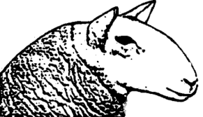Purebred Sheep Breeders’ Association of Nova Scotia

Interested in Becoming a Member??
Membership with PSBANS:
- A 1-year membership to cost $20.00 per member.

- Members of the Association Participating in the annual Atlantic Sheep Sale will receive a full refund of their registration fees if their animal sells. (Non-member’s registration fees will not be refunded, regardless of if their animal sells.)

- Discount rates for participation in events sponsored by PSBANS. Workshop’s etc.

- Discounts for participation in promotional projects (i.e., a printed Breeders Directory, Fall Sale Catalogue, advertising on PSBANS website or a link to the website).

- Voting privilege at the PSBANS AGM for year of enrollment.

*Personal info to be used for administration purposes only or as described above.

Membership Application:

Name(s): ______________________________________________________________
Mailing Address: ________________________________________________________
Postal Code: ___________________________________________________________
Telephone: ____________________________________________________________
Email: ________________________________________________________________
Date: _________________________________________________________________

Please make cheques payable to PSBANS
OR e-transfer to: Dianne Sinclair, Treasurer, Psbans.secretary@hotmail.com
Return your filled in form by email (janessa.henry@dal.ca ) or mail
PSBANS, c/o Janessa Henry, Secretary, 438 Smithville Rd. Mabou, NS B0E 1X0

